**Seashell Treasure**

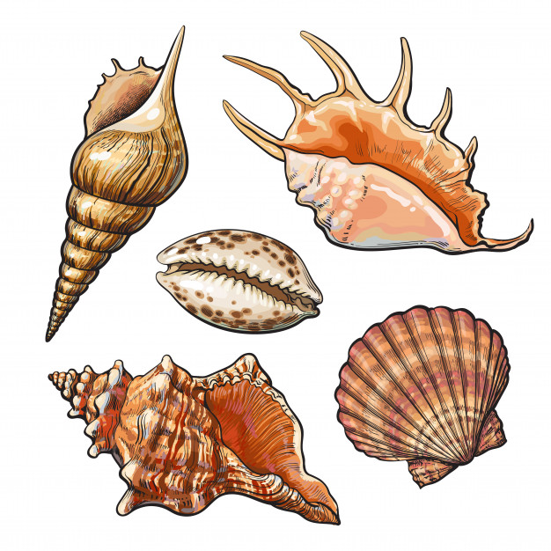

*It's beautiful summer afternoon and you decide to go to the beach and collect some seashells. There will be three types of seashells (the most beautiful in the world) - Cockle, Nautilus and Moonshell. But you are not alone at the beach - the Seagull Gully is on his watch and also wants to steal some seashells.*

First you will be given the number of **rows** of the beach - **integer n**. On the next **n** lines you will receive the available seashells to collect for each row, **separated by single space** in the format:

**"{seashell1} {seashell2} … {seashelln}"**

If there is **not** a seashell at some positions, the cell is considered empty and will be marked with **dash ('-').**

After that you will start receiving **commands**. There are **three** possibilities:

* **"Collect {row} {col}"** - you have to go to the given place **if you can** and collect the seashell, **if** there is one. When you **collect** it, you have to mark the place as an **empty**, using **dash ('-')** symbol.
* **"Steal {row} {col} {direction}"** - the evil Gully lands at the given coordinates and **takes 3 steps in the given direction**. He **steals** the seashells **if** **there are any** in the visited cells and also mark them as **empty ('-')**. If the **given** **coordinates** are **invalid**, Gully **cannot land**, you are lucky - he doesn't steal seashells and continue circling around. There are four possible directions:
* **"up", "down", "left", "right"**
* **"Sunset"** - it's getting late and you **stop** collecting seashells.

In the end, print on the console the **last condition of the beach**. The cells, containing a seashell or not, should be **separated by single space**. After that print the **count** of the seashells you've collected and if they are **one or more** - list them in **order of collecting**, separated by **comma and space**:

**"Collected seashells: {countOfCollectedSeashells} -> {seashell1}, {seashell2}, …, {seashelln}"**

Last step is to print the number of **stolen** by Gully seashells in the format:  
"**Stolen seashells: {countOfStolenSeashells}"**

## Input

* On the first line, you will receive the number of beach's **rows** - **integer n**
* On the next **n** lines, for each row, the situation of the **seashells** at the beach in the described **format** above
* Next, until you receive **"Sunset"**, you will get the **commands** in the specified format.

## Output

* Print the **resulting** beach - each cell, separated **by single space**
* On the next output line - print information for **seashells** you've **collected** in the **described** format
* On the last line - print the **number** of seashells **stolen** by the seagull

## Constraints

* The number of **rows** will be **positive** **integer** between **[1, 10]**
* The **types** of seashells will always be **'C', 'N', 'M'**
* Move commands will be: "**up**", "**down**", "**left**", "**right**"

## Examples

|  |  |  |
| --- | --- | --- |
| ****Input**** | ****Output**** | ****Comment**** |
| **6**  **C N - M C - N**  **- N - -**  **N - M - C N - -**  **- C - M - C**  **M N**  **C M N - C**  **Collect 2 2**  **Collect 4 1**  **Steal 3 1 up**  **Collect 4 3**  **Collect 5 0**  **Collect 4 0**  **Steal 2 0 down**  **Sunset** | **C - - M C - N**  **- - - -**  **- - - - C N - -**  **- - - M - C**  **- -**  **- M N - C**  **Collected seashells: 4 -> M, N, C, M**  **Stolen seashells: 4** | First we receive **"Collect"** command, we go to the given coordinates and collect the **'M'** and leave its cell **empty ('-')**. At the same way we collect and **'N'** for the next command. After that there is **"Steal"** command - the seagull **lands** at coordinates **3 1**, first collects **'C'**, then takes **3 steps up** - the first cell is **empty**, so he continues up, on the **second** step he steals **'N'** and on the **third** - **'N'** and sets their cells as **empty**. The **"Collect"** command is next, but we **don't do** anything, because the coordinates are **invalid**. We execute the last commands in the same way. In the end we print the beach. We've collected **4** seashells, so we print them in order **"M, N, C, M"**. The seagull managed to **steal** **4** seashells. |
| 4  - N M  C  M - - -  N  Collect 9 0  Collect 1 4  Steal 0 2 right  Steal 5 5 up  Sunset | **- N -**  **C**  **M - - -**  **N**  **Collected seashells: 0**  **Stolen seashells: 1** | **The **"Collect"** commands are **skipped**, because of the **invalid** **coordinates**. When we receive "**Steal"** command, the seagull steals the **'M'**, leaves it **empty** and he **can't** go 3 steps right, so the program **continues**. The next command is also **"Steal"** but the seagull **cannot** land so he **doesn't steal** anything. There are **no more** commands and the program ends.**  **We **didn't collect** any seashells, so we **print** the given final messages.** |